How To Write DirectMusic Producer DX8 Strip Editors

This document is confidential and contains highly sensitive information about Microsoft’s product development plans. This is a proprietary work owned by Microsoft Corporation, and is maintained as a trade secret. Unless provided for under an appropriate Non-Disclosure Agreement, this document may be shared only with authorized personnel at Microsoft. Discussion or transmission of this document (as well as any associated discussions about the contents of this document) to any unauthorized Microsoft personnel is specifically prohibited. Complying with all applicable copyright laws is the responsibility of the user. This document is Copyright © 1999 –2000 Microsoft Corporation. All rights Reserved. Without limiting the rights under copyright law, no part of this document may be reproduced, stored in or introduced into a retrieval system, or transmitted in any form or by any means (electronic, mechanical, photocopying, recording, or otherwise), or for any purpose, without the express written permission of Microsoft Corporation, One Microsoft Way, Redmond, WA 98052. Microsoft may have patents or pending patent applications, trademarks, copyrights, or other intellectual property rights covering subject matter in this document. Except as expressly provided in any written license from Microsoft, the furnishing of this document does not give you any license to these patents, trademarks, copyrights, or other intellectual property rights.

Table of Contents
Introduction 3

Overview 3

Segment Designer Window 4

Active Strip and Gutter Selected Strips 5

Time Strip and Gutter Selection 5

Track Groups 5

Interfaces 6
Strip Manager Implementation Guidelines 8

System Registry 8

Interfacing with the Timeline 9

Interfacing with the Segment Designer 13

Interfacing with the DirectMusic Track 15

Interfacing with the Property Sheet 16

Strip Implementation Guidelines 17

Active Strip 17

Edit Menu Functionality 17

Drag and Drop Functionality 19

Drawing 19

Strip Wizard Usage Guidelines 21

Overview 21

Introduction

Overview
A DirectMusic segment is simply a block of time containing a collection of tracks. For more information on how segments and tracks relate, please review the topic “DirectX Audio\Using DirectX Audio\Playing Sounds\Using Segments” in the DirectX API documentation.
Producer’s Segment Designer Component (SegmentDesigner.ocx) manages the editing of DirectMusic segment files. The Segment Designer displays each DirectMusic track as a “strip” in a Timeline window. The interaction between a DirectMusic Segment and its tracks is very similar to the interaction between the Producer Segment Designer and its strip managers.
Strip managers are the editor modules that edit DirectMusic tracks. The mechanism by which they interact with the Segment Designer is relatively simple:
- Strip managers are COM objects, typically hosted in DLLs (i.e. BandStripMgr.dll) that load into DirectMusic Producer’s process space.
- The Segment Designer keeps track of which strip managers edit which DirectMusic tracks via the Windows registry.
- Strip manager objects are created by the COM CoCreateInstance call. Each strip manager object provides its functionality through interfaces. Each interface can be addressed via the standard COM QueryInterface call.
- Each strip manager is responsible for loading and saving its RIFF data chunks to a stream. The Segment Designer manages the process of formatting these chunks into a complete Segment file.
The remainder of this document explains how to create strip managers and strips that plug into Producer’s Segment Designer.

Segment Designer Window
When the Segment Designer window is open, each strip is hosted within a Timeline object. The Timeline manages the display and interaction between the strips, while the Segment Designer manages the persistence of data stored within the strip managers.
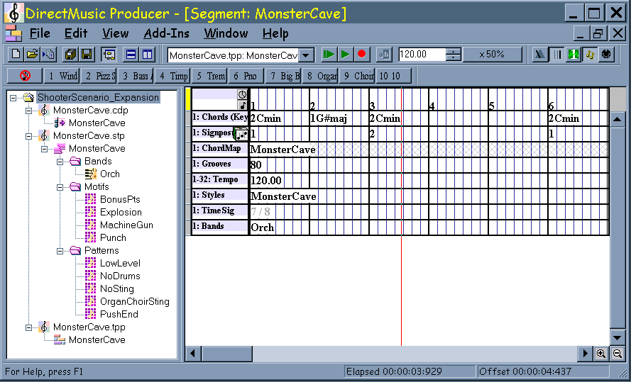

When creating a new Segment, an empty Timeline window is displayed. The only strips that are visible are the “Time Strip”, which divides the segment into measures and beats, and the Time Signature strip.
The user adds tracks to a segment by choosing “Add Track(s)...” from the Edit menu or the right-click menu, or pressing Ctrl+Ins. The Segment Designer looks under the key [HKEY_LOCAL_MACHINE\SOFTWARE\Microsoft\DMUSProducer\StripEditors] in the system registry for registered track types and then presents their names in the “Add New Tracks” dialog box.
Once a strip exists in the Segment, the user may edit it with whatever facilities the strip provides.
To remove a strip from the Segment, the user clicks on its gutter (the small gray box the left of the strip) then chooses “Delete Track(s)” from the Edit menu or the right-click menu, or presses Ctrl+Del. All strips that have their gutters selected will then be removed.
Strips do not have any inherent length – the length of the segment that contains them determines their length.
If, when loading a segment, the Segment Designer encounters a strip without a registered Strip Manager, the strip displays via a default “Unknown Strip” manager that simply displays the number of bytes of data in the track.

Active Strip and Gutter Selected Strips
The rectangular button at the far left of each strip is called a “gutter”. The gutter is displayed in different colors, depending on the state of its corresponding strip.
The active strip is displayed with a yellow gutter. The active strip is the strip currently being edited. It receives keyboard input and should display a property page to allow editing of its data.
Gutter-selected strips are displayed with red gutters. Gutter-selected strips are used with selections in the top time strip to allow for multiple-strip cut, copy, and paste operations.
A strip that is both active and gutter-selected is displayed with an orange (yellow plus red) gutter.

Time Strip and Gutter Selection
The time strip is always displayed at the top of the Segment Designer window. It allows a region of time to be selected, and is most often used in conjunction with the strip gutters to accomplish multiple-strip cut, copy, and paste. For example, click on the gutters of several strips to gutter-select the strips. Their gutters will turn red. Now highlight a region of time in the time strip and see how the corresponding areas in the gutter-selected strips become highlighted. Select Edit/Copy to place a copy of the data from the selected regions in all gutter-selected strips into the clipboard.

Track Groups
Within a segment, each strip manager belongs to one or more track groups. The track group setting is a 32-bit number, where each bit represents a different track group. Track groups are used for determining where a track retrieves data that it requires (such as chord or groove information), or for determining where a track provides data (such as chord or groove information). For example, a style track in track group 3 looks for chords on a chord track belonging to track group 3. By using different track groups, a composer could have up to 32 simultaneous time signatures or chords.

Interfaces
The following diagram shows the interfaces implemented by the Segment Designer object and the Timeline object and how they relate to the strips and strip managers. The interfaces in bold type must be implemented for basic functionality to work. The interfaces in normal type are strongly suggested, and are necessary to allow editing from the property page. The interfaces in italic type are useful for more advanced functionality, such as drag and drop and customizations within the function bar area.
For a more detailed explanation of these interfaces please refer to the Producer API reference, which is contained in IDMUSPROD.HLP. After opening IDMUSPROD.HLP, click the “Index” button, type “interfaces” and then hit <Enter>. A complete listing of Producer interfaces will be displayed.
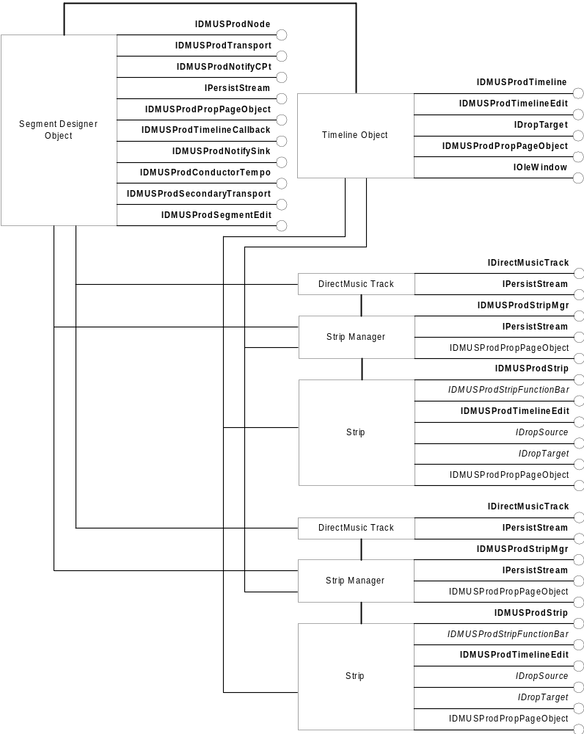

Strip Manager Implementation Guidelines

System Registry
DLLs are required to self-register their components. MFC or ATL may take care of OLE specific entries, but the DLL must register/unregister the DirectMusic Producer specific entries for each control in DLLRegisterServer and DLLUnregisterServer respectively.
Each strip manager must register itself as follows under:

[HKEY_LOCAL_MACHINE\SOFTWARE\Microsoft]
[HKEY_LOCAL_MACHINE\SOFTWARE\Microsoft\DMUSProducer]
[HKEY_LOCAL_MACHINE\SOFTWARE\Microsoft\DMUSProducer\StripEditors]

[HKEY_LOCAL_MACHINE\SOFTWARE\Microsoft\DMUSProducer\StripEditors\
{EE279463-B2E5-11D1-888F-00C04FBF8D15}]
@=”Lyric Track”
StripManager=”{EE279466-B2E5-11D1-888F-00C04FBF8D15}”

The key name under [HKEY_LOCAL_MACHINE\SOFTWARE\Microsoft\ DMUSProducer\StripEditors] is the CLSID of the DirectMusic track the strip manager edits. The default value of that key is the name displayed in the “Add New Tracks” dialog. The value “StripManager” is the CLSID of the strip manager object.
Each strip manager also needs to register itself as follows under:

[HKEY_CLASSES_ROOT\CLSID\
{EE279466-B2E5-11d1-888F-00C04FBF8D15}]
@=”LyricMgr Class”

[HKEY_CLASSES_ROOT\CLSID\
{EE279466-B2E5-11d1-888F-00C04FBF8D15}\InProcServer32]
@=”C:\Program Files\DirectMusic Producer\LyricStripMgr.dll”
ThreadingModel=”Apartment”

These keys are typically registered automatically by MFC or ATL helper code.

Interfacing with the Timeline
Strip Managers and Strips
A strip manager “manages” the underlying data of one or more strips. A strip is what actually displays in the Segment Designer window. It provides the UI a composer uses to edit and access data within the track.
In most cases, one strip manager controls one strip, and all editing occurs through that one strip. For tracks that contain more than one type of data, however, it may make more sense to implement more than one strip. For example, a sequence contains both notes and curves and the sequence strip manager provides separate strips for editing each kind of data.
Typically, a strip manager creates the strip(s) it manages once, when the strip manager is created. Alternatively, it could create a strip each time it is added to the timeline, and delete the strip when the strip manager is removed from the timeline.
If the same strip is added and removed from the timeline repeatedly, it must be re-initialized by the strip manager each time it is added to the timeline. Otherwise, the strip may erroneously think its gutter is selected or it may not know the current start and end selection points.

Adding and Removing Strip Managers from the Timeline
When a strip manager is added to the timeline, the property SMP_ITIMELINECTL is set with a pointer to the timeline via a call to IDMUSProdStripMgr::SetStripMgrProperty. The strip manager should add its strip(s) to the timeline at this point. It should also register for any notifications it would like to receive.
When a strip manager is removed from the timeline, the property SMP_ITIMELINECTL is set to NULL via a call to IDMUSProdStripMgr::SetStripMgrProperty. The strip manager should remove its strip(s) from the timeline at this point. It should also unregister any previously registered notifications.
The following example shows how the style strip manager handles SMP_ITIMELINECTL in its SetStripMgrProperty method:
HRESULT CStyleRefMgr::SetStripMgrProperty(
STRIPMGRPROPERTY stripMgrProperty, VARIANT variant)
{
AFX_MANAGE_STATE(AfxGetStaticModuleState( ));

switch( stripMgrProperty )
{
case SMP_ITIMELINECTL:
if( variant.vt != VT_UNKNOWN )
{
return E_INVALIDARG;
}
if( m_pTimeline )
{
// We were previously attached to a timeline, so clean up
m_pTimeline->RemovePropertyPageObject(
(IDMUSProdPropPageObject *)this );
if ( m_pStyleRefStrip )
{
m_pTimeline->RemovePropertyPageObject(
(IDMUSProdPropPageObject *)m_pStyleRefStrip );
m_pTimeline->RemoveStrip((IDMUSProdStrip*)m_pStyleRefStrip);
}

// Timeline automatically removes us from notify lists

m_pTimeline->Release();
m_pTimeline = NULL;
}

if( V_UNKNOWN( &variant ) )
{
if( FAILED( V_UNKNOWN( &variant )->QueryInterface(
IID_IDMUSProdTimeline, (void**)&m_pTimeline ) ) )
{
return E_FAIL;
}
else
{
m_pTimeline->InsertStripAtDefaultPos(
(IDMUSProdStrip *)m_pStyleRefStrip,
CLSID_DirectMusicStyleTrack, m_dwGroupBits, 0 );
m_pTimeline->AddToNotifyList( (IDMUSProdStripMgr *)this,
GUID_Segment_AllTracksAdded, m_dwGroupBits );
m_pTimeline->AddToNotifyList( (IDMUSProdStripMgr *)this,
GUID_Segment_FrameworkMsg, m_dwGroupBits );
}
}
break;

return S_OK;
}

Notifications
Strip managers use notifications to notify other strip managers in the segment that some type of data has changed or that some event has occurred. For example, when the user changes the time signature in the time signature strip, it calls IDMUSProdTimeline::NotifyStripMgrs to notify all other strips in its track group that the time signature information has changed. This allows the other strip managers to adjust their data to account for the new time signature.
Strip managers must call IDMUSProdTimeline::AddToNotifyList once for each type of each notification they are interested in receiving. The requested notifications are sent to the strip manager’s IDMUSProdStripMgr::OnUpdate method.
Here is a table of the notifications sent by each of the standard strip managers in DX8:

Chord | GUID_ChordParam – sent when a chord is inserted, deleted, or changes  GUID_ChordKey – sent when the key changes  GUID_ChordSharpsFlats – send when the key changes
Signpost | None
ChordMap Reference | None
Groove | None
Tempo | GUID_TempoParam – sent when a tempo is inserted, deleted, or changes
Style Reference | GUID_TimeSignature – sent when a style is inserted, deleted, or changes  GUID_Segment_NewStyleSelected – sent when a style changes
Sequence | GUID_Sequence_Notation_Change – sent when the user changes the notation type  GUID_Sequence_Quantize – sent when the user optimizes all parts
Time Signature | GUID_TimeSignature
Band | GUID_Segment_BandTrackChange
Mute | None
Lyric | None

The Segment Designer sends notifications of its own. Here is a table of the notifications it sends:

GUID_Segment_AllTracksAdded | Sent when the segment editor window is opened, after all strip managers are added.  Sent after the user chooses to do an Undo or Redo, after all strip managers are removed and re-added.
GUID_Segment_Length_Change | Sent after the user chooses to do an Undo or Redo and the length changes, after all strip managers are removed and re-added, but before GUID_Segment_AllTracksAdded is sent.  Sent after the user changes the length of the segment from the segment property page.  Sent after the segment’s length is changes as a result of changing a time signature in the track group the segment gets its time signature from.
GUID_IDirectMusicStyle | Sent when the user adds a new Style track, or when the user deletes a Style track.
GUID_Segment_Start | Sent when the segment starts playback.
GUID_Segment_Stop | Sent when the segment stops playback.
GUID_Segment_RecordButton | Sent when the record button state is changed (up/down).
GUID_Segment_FrameworkMsg | Sent when the segment node receives a framework message.
GUID_Segment_WindowActive | Sent when the segment editor’s window is activated or deactivated.
GUID_TimeSignature | Sent when a Style or Time Signature track are added.
GUID_Segment_CreateTrack | Sent to a strip manager after the user uses the “Add New Tracks…” menu item to add it.
GUID_Segment_DeletedTrack | Sent to a strip manager after the user uses the “Delete Tracks…” menu item to remove it.

The Timeline also sends a notification of its own:

GUID_TimelineSetCursor | Sent whenever the time cursor in the Timeline is moved.

Interfacing with the Segment Designer
Persisting Data
The segment designer persists data to and from the strip manager by using the Load and Save methods of the IPersistStream interface. The Load method is used to add data to the strip manager when the segment is first loaded, and to add data to the strip manager after an Undo or Redo operation. The Save method is used to persist data back into the segment designer for use in the undo queue and for saving to a file on disk.
When saving data, a strip manager should not save design-time data in a runtime file. The type of save to do can be accessed by querying the stream for its type:
// Structures for determining the stream type
DMUSProdStreamInfo StreamInfo;
FileType ftFileType = FT_RUNTIME;
GUID guidDataFormat = GUID_CurrentVersion;

// Get additional stream information
IDMUSProdPersistInfo* pPersistInfo;
if( SUCCEEDED ( pIStream->QueryInterface(
IID_IDMUSProdPersistInfo, (void **)&pPersistInfo ) ) )
{
pPersistInfo->GetStreamInfo( &StreamInfo );
ftFileType = StreamInfo.ftFileType;
guidDataFormat = StreamInfo.guidDataFormat;
pPersistInfo->Release();
}
ftFileType will contain the type of save to do. It will contain either FT_RUNTIME or FT_DESIGN.
In the future, the segment designer may support more than one file format. For now, the only data format used by the Segment Designer is GUID_CurrentVersion. A strip manager may wish to use GUID_DirectMusicObject when it persists itself to the DirectMusic Track object it edits.

Handling Data Changes
The strip manager should call IDMUSProdTimeline::OnDataChanged with a pointer to its IDMUSProdStripMgr interface when any of the data inside the strip manager changes. This may occur when the user changes data within a strip, or when the data changes as a result of receiving a notification (e.g., a time signature change). This ensures that the segment designer always has an up-to-date copy of the data for use in the undo and redo queues.
The segment designer uses the timeline property TP_FREEZE_UNDO to collapse multiple changes into one item in the undo queue. When this property is set to true, the segment designer does not add an item to the undo queue when OnDataChanged is called. When this property is set to false, the segment designer adds an item to the undo queue when OnDataChanged is called.
A strip manager is also responsible for updating its DirectMusic Track object whenever data within the strip changes.
Undo and Redo
During an Undo or Redo operation, the segment designer first removes all strip managers from the timeline and releases them (which should cause them to be deleted). It then creates new strip managers, loads the data into them, then adds them back to the timeline.
If a strip manager wants to customize the text displayed in the Undo and Redo menu items (highly recommended), it should support GUID_Segment_Undo_BSTR in its IsParamSupported and GetParam methods.
Here is an example of how to handle this in GetParam:

// Check if the segment is asking for a string to display in the
// Undo and Redo edit menu items
if( ::IsEqualGUID( guidType, GUID_Segment_Undo_BSTR ) )
{
// Ensure pData is valid
if( pData == NULL )
{
// Invalid pData pointer – return failure code
return E_POINTER;
}

// Try and load our current undo string
CComBSTR comBSTR;
if( comBSTR.LoadString( m_nLastEdit ) )
{
// Succeeded - return the BSTR
*(BSTR*)pData = comBSTR.Detach();
return S_OK;
}
return E_FAIL;
}

Interfacing with the DirectMusic Track
Overview
The Segment Designer will create the DirectMusic Track object that a strip manager is responsible for editing. It will pass a pointer to this object by setting the strip manager’s SMP_IDIRECTMUSICTRACK property with a pointer to the track’s IDirectMusicTrack interface.
A strip manager is responsible for ensuring the DirectMusic Track is always up-to-date with any changes made in the strip in the Segment Designer. It is recommended that the track be updated any time the Segment Designer is updated.

Example
The following code snippet shows how a typical track may be updated:

// Create a memory stream to use
IStream* pIMemStream = NULL;
HRESULT hr = m_pDMProdFramework->AllocMemoryStream( FT_RUNTIME,
GUID_DirectMusicObject, &pIMemStream );
if( SUCCEEDED ( hr ) )
{
// Ensure the stream is at the beginning
StreamSeek( pIMemStream, 0, STREAM_SEEK_SET );

// Save ourself
hr = Save(pIMemStream, FALSE);
if ( SUCCEEDED( hr ) )
{
// Query the track for its IPersistStream interface
IPersistStream* pIPersistStream = NULL;
hr = m_pIDMTrack->QueryInterface(IID_IPersistStream,
(void**)&pIPersistStream);
if ( SUCCEEDED( hr ) )
{
// Seek back to the beginning of the stream
StreamSeek( pIMemStream, 0, STREAM_SEEK_SET );

// Load the DirectMusic Track with the new data
hr = pIPersistStream->Load(pIMemStream);

// Release the track's IPersistStream interface
pIPersistStream->Release();
}
}

// Release the reference to the memory stream
pIMemStream->Release();
}

For the above code to work, the track must be able to safely reload itself during playback. Using critical sections or another synchronization mechanism around data access in the track is highly recommended.

Interfacing with the Property Sheet
Overview
The property sheet is where the user spends most of their time editing the data in a strip. The property page is accessed via the interface IDMUSProdPropPageManager. The property page accesses and updates data in the strip manager via the interface IDMUSProdPropPageObject.
Data is typically passed through a structure returned in the GetData method, and set in the SetData method. The intelligence for handling invalid data may be implemented either in the property page or in the strip manager. Either way, the property page should correctly handle or disallow the user from moving an item to a beat or measure that doesn’t exist (e.g., moving to the 5th or 0th beat of a 4/4 measure, or moving to measure 30 of a 15 bar segment).
The property page that handles editing of the actual items within a strip is typically implemented with the strip manager as the property page object. The property page that handles editing of strip-wide items, such as track group bits or key signature, is typically implemented with the strip as the property page object.

Strip Implementation Guidelines

Active Strip
A strip becomes the active strip when the Timeline sends it the message WM_SETFOCUS. It loses its active strip status when the Timeline sends it the message WM_KILLFOCUS.
When the strip becomes active, it should tell the Timeline to display one of its property pages. If nothing is selected in the strip, it is recommended to display the strip property page (track group bits property page). When something is selected in the strip, it is recommended to display the strip manager’s property page.
The strip accomplishes this by calling the method IDMUSProdTimeline::SetPropertyPage with a pointer to the respective property page manager and property page object.
When a strip receives the WM_KILLFOCUS message and loses focus, it should call IDMUSProdTimeline::RemovePropertyPageObject to ensure that its property page is no longer displayed. This avoids confusing situations where one strip may be active, but the property page for another strip is still displayed.

Edit Menu Functionality
Strips hook into the main Edit menu (Cut, Copy, Paste, Insert, Delete, Select All) and the default right-click context menu by implementing the IDMUSProdTimelineEdit interface. During a right-click context menu operation, the strip will receive the user’s choice as a WM_COMMAND message in its IDMUSProdStrip::OnWMMessage method. If the user chooses an item from the main Edit menu, the appropriate methods from IDMUSProdTimelineEdit will be called directly.
The Timeline handles the main Edit menu in two different ways:
- If there is at least one gutter-selected strip, and there is a non-empty range selected in the time strip, the timeline will do a multiple strip edit operation.
- Otherwise, the timeline will do a single strip edit operation on the active strip.
The Insert operation is always performed on the active strip only, irrespective of the gutter selection state of the strips.

Single Strip Edit operation
For this, the timeline uses only the IDMUSProdTimelineEdit interface on the active strip to enable the correct items in the edit menu and to process them when the user chooses a menu item.
NULL will be passed as the argument to the Cut, Copy, and Paste methods.
Multiple Strip Cut, Copy, Paste
For this, the timeline will coordinate moving data to and from the clipboard. Before the edit menu is displayed, it will check through all gutter-selected strips to determine if any of them support each edit operation. If at least one supports it, the timeline will enable the corresponding edit menu option. When the user chooses an edit menu option, the timeline will query each gutter-selected strip to see if it supports the operation. If the strip supports the operation, the timeline will then call the respective method.
For the Cut operation, the timeline will first cut data from all strips that do not support time signature information (in vertically descending order), then it will cut the time signature information. This allows the time signature information to be available when the data in the other strips is cut. The timeline will pass to each gutter-selected strip’s Cut method an IDMUSProdTimelineDataObject with the boundary information already set. The strip must add its clipboard format to the object by calling the AddInternalClipFormat method. It may add data by using the AddExternalClipFormat if the strip can provide its data in a format that is usable by other applications. Most strips implement the Cut operation as a Copy operation followed by a Delete operation.
For the Copy operation, the timeline will copy data from each gutter-selected strip in vertically descending order. It will pass to each strip an IDMUSProdTimelineDataObject with the boundary information already set. The strip must add its clipboard format to the object by calling the AddInternalClipFormat method. It may add data by using the AddExternalClipFormat if the strip can provide its data in a format that is usable by other applications.
For the Paste operation, the timeline will paste first to all gutter-selected strips that support time signature information, then to the rest of the gutter-selected strips. This allows the time signature information to be available when the data is pasted into the other strips. The timeline will pass to each gutter-selected strip’s Paste method an IDMUSProdTimelineDataObject with the boundary information set. The strip should then use the IsClipFormatAvailable method to query for its information, then call AttemptRead to actually get the data. Since more than one strip of the same type may take part in a multiple strip operation, AttemptRead must be called only once for each clipboard type by each strip.
When performing a multiple-strip cut or copy operation, a strip must return S_OK from its CanCopy and CanCut methods, even if nothing is selected in the strip. The Cut and Copy method must also return S_OK and copy empty data to the clipboard. This ensure data does not end up in the wrong position when the user copies and pastes multiple strips of the same type.

Drag and Drop Functionality
If a strip wishes to support drop functionality, it must implement the IDropTarget interface. The Timeline will call the appropriate methods in this interface when the user drags an object over the strip. The strip does not need to do any type of registration for drop functionality, other than supporting IID_IDropTarget in QueryInterface.
If a strip wishes to support drag functionality, it must implement the IDropSource interface. The strip does not need to do any type of registration for drop functionality, other than supporting IID_IDropSource in QueryInterface. To start a drag and drop operation, the strip should use the DoDragDrop method, documented in the Platform SDK.
To be consistent with the existing strips, a drag and drop operation should not start until the user moves the mouse cursor after clicking on an item. This keeps a purposeless drag and drop operation from occurring when the user clicks on an item in the strip.

Drawing
The Timeline calls the method IDMUSProdStrip::Draw to allow a strip to display itself inside the Segment Designer. The strip is passed a device context that has the clipping regions and vertical scrolling information built in. Horizontal scrolling is accomplished by using the lXOffset parameter of this method to offset the strip’s display by a pixel amount. The Timeline always clears the background of the region the strip is asked to draw to the standard window background color. It is recommended that a strip call IDMUSProdTimeline::DrawMusicLines to draw vertical bar and beat lines inside the strip.
Most strips in the segment designer display their data on beat or measure boundaries. This makes the display cleaner and makes it easier for the user to move data accurately to another beat or measure. Even though the data may be stored in the file as at a certain number of clocks into the segment, during editing that number is converted to a measure and beat value plus an offset.
When a strip’s gutter is selected and there is a region of time selected in the time strip, the strip should draw the selected region in inverse video, with the start and end points snapped to the default granularity of the strip. For strips that display with beat granularity, this may be accomplished by the following code:
// Highlight the selected range if there is one.
if(m_bGutterSelected && m_lGutterBeginSelect != m_lGutterEndSelect )
{
// Compute the start and end selection times
long lBeginSelect = m_lGutterBeginSelect > m_lGutterEndSelect ?
m_lGutterEndSelect : m_lGutterBeginSelect;
long lEndSelect = m_lGutterBeginSelect > m_lGutterEndSelect ?
m_lGutterBeginSelect : m_lGutterEndSelect;

// Convert the start and end times to and from a measure plus beat time
// This snaps the range we invert to the include the beat the start
// and end times are within.
long lMeasure, lBeat;
m_pTempoMgr->m_pTimeline->ClocksToMeasureBeat(
m_pTempoMgr->m_dwGroupBits, 0, lBeginSelect, &lMeasure, &lBeat );
m_pTempoMgr->m_pTimeline->MeasureBeatToPosition(
m_pTempoMgr->m_dwGroupBits, 0, lMeasure, lBeat,
&(rectHighlight.left));

m_pTempoMgr->m_pTimeline->ClocksToMeasureBeat(
m_pTempoMgr->m_dwGroupBits, 0, lEndSelect, &lMeasure, &lBeat );
m_pTempoMgr->m_pTimeline->MeasureBeatToPosition(
m_pTempoMgr->m_dwGroupBits, 0, lMeasure, (lBeat + 1),
&(rectHighlight.right));

rectHighlight.left -= lXOffset;
rectHighlight.right -= lXOffset;

// Invert it.
dc.InvertRect( &rectHighlight );
}

Strip Wizard Usage Guidelines

Overview
To use the Strip Wizard with Microsoft Visual C++ 6.0, copy the file \bin\StripWizard.awx to C:\Program Files\Microsoft Visual Studio\Common\MSDev98\Template. In Visual C++'s New Projects dialog, "Strip AppWizard" will now appear. This wizard may be used to create a new strip editor that is functionally identical to the sample LyricStripMgr, but with a different name and with different Class and Interface IDs.
The project generated by the Strip AppWizard assumes that the files in the DirectMusic Producer SDK directory \samples\Shared will be copied to the directory ..\shared. If this is not the case, the project’s include path must be updated to point to the correct directory, and the files BaseMgr.cpp, BasePropPageManager.cpp, BaseStrip.cpp, GroupBitsPPG.cpp, RiffStrm.cpp, SelectedRegion.cpp, and StaticPropPageManager.cpp must be removed from the project and re-added from the correct location.
The project also assumes that the files in the DirectMusic Producer SDK directory \include will be copied to the directory ..\include. If this is not the case, the project’s include path must be updated to point to the correct directory.
Before the generated project will compile, the path to the include and library files for the DirectX 8.0 SDK must be added to each configuration.

